**DSO 510: Homework 3**

**Submitted by:**

**Shree Vidya Ravi Kumar (Cohort A)**

**Falak Jain (Cohort B)**

**Exercise 1:**

1. Closeness centrality (F):

CC(x) = (N-1)/∑y!=x d(y,x)

CC(F) = (8-1)/(3+2+3+2+1+1+1)

= 7/13

= 0.54

Explanation:

N = 8

Shortest Path from F:

To A: 3 🡪 F-G-B-A

To B: 2 🡪 F-G-B

To C: 3 🡪 F-G-B-C

To D: 2 🡪 F-E-D

To E: 1 🡪 F-E

To G: 1 🡪 F-G

To H: 1 🡪 F-H

1. Betweenness centrality (D):

BC(x) = ∑ number of shortest paths from a to b through node x

--------------------------------------------------------------------

number of shortest paths from a to b

= 1/1 + 1/1 + 1/1 = 3

Explanation:

From nodes:

A-E = number of shortest paths from A to E passing through D = 1

total number of shortest paths from A to E = 1

Therefore, BC = 1/1

A-F = 0/1

A-G = 0/1

A-H = 0/1

B-E = 1/1

B-F = 0/1

B-G = 0/1

B-H = 0/1

C-E = 1/1

C-F = 0/1

C-G = 0/1

C-H = 0/1

**Exercise 2:**

* The total number of departments in the file is 3
* 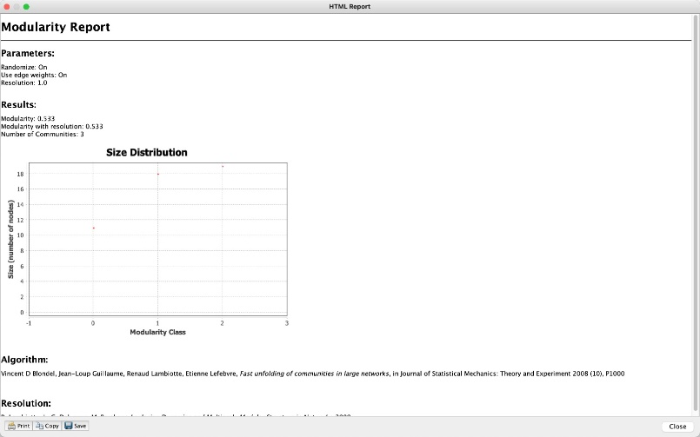
* Employee 47 is in the same department as employee 46 as they are both assigned to modularity class 2
* 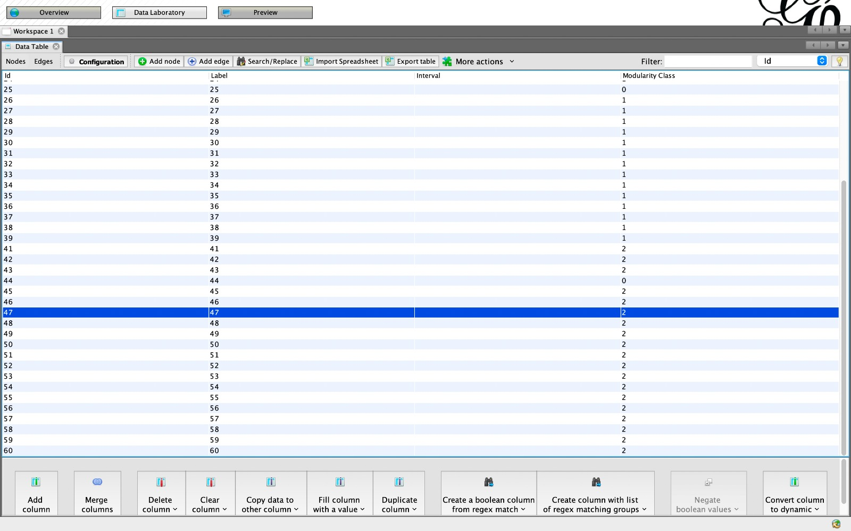
* Connections of employee 60: 12 (49,57,56,46,42,52,47,48,55,54,53,58)
* 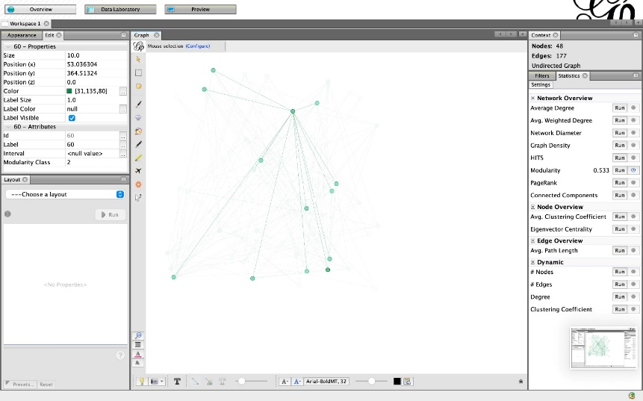
* Connections of employee 35: 9 (24,33,28,55,37,25,34,21,38)
* 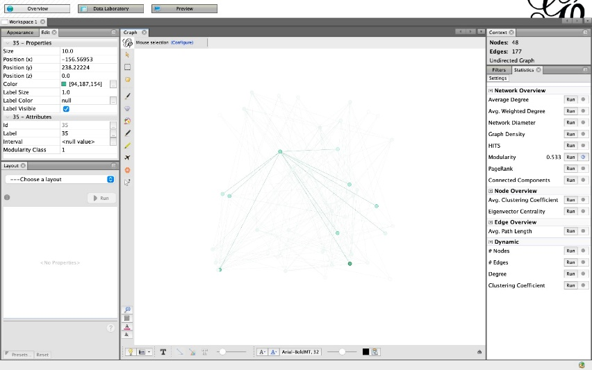
* Connections of employee 25: 4 (35,7,44,34)
* 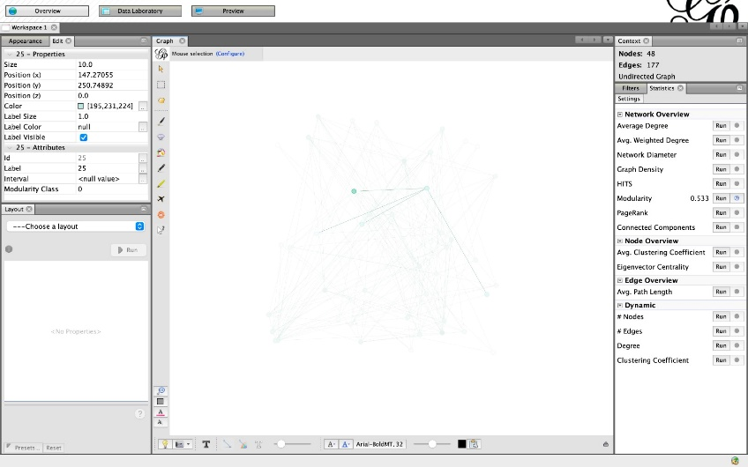
* Employee 60 is connected to the most employees; however, all these employees belong to the same department and therefore employee 60 has no connections outside the department.
* Employee 25 is connected to just 4 employees but 2 of them (35,34) are from another department
* Employee 35 has 9 connections from which 55 and 25 belong to different departments and 55 and 25 do not belong to the same dept.
* Therefore 35 has connections in every department of the organization and should be awards for doing a good job of connecting departments

**Exercise 3:**

1. 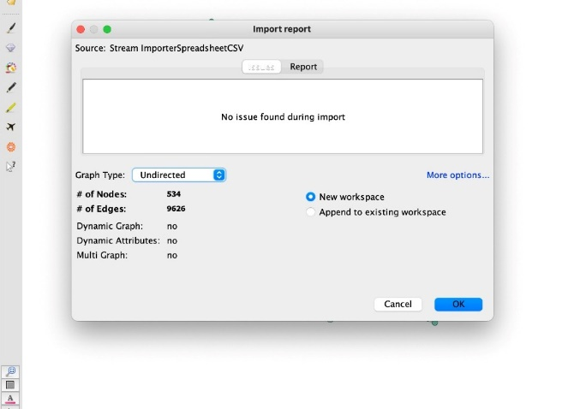
2. 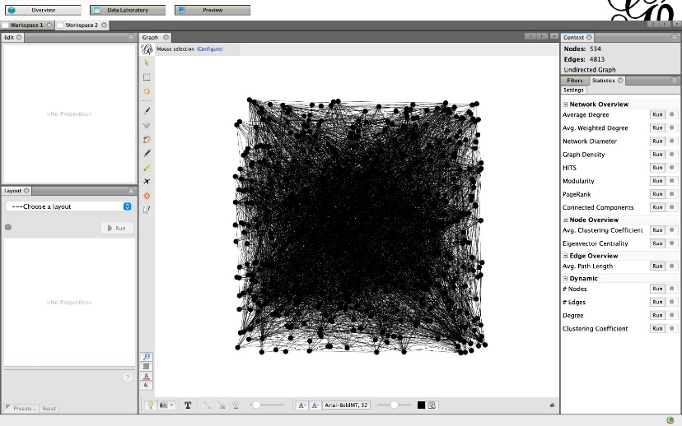

Therefore, the network includes 4813 edges and 534 Facebook friends

1. 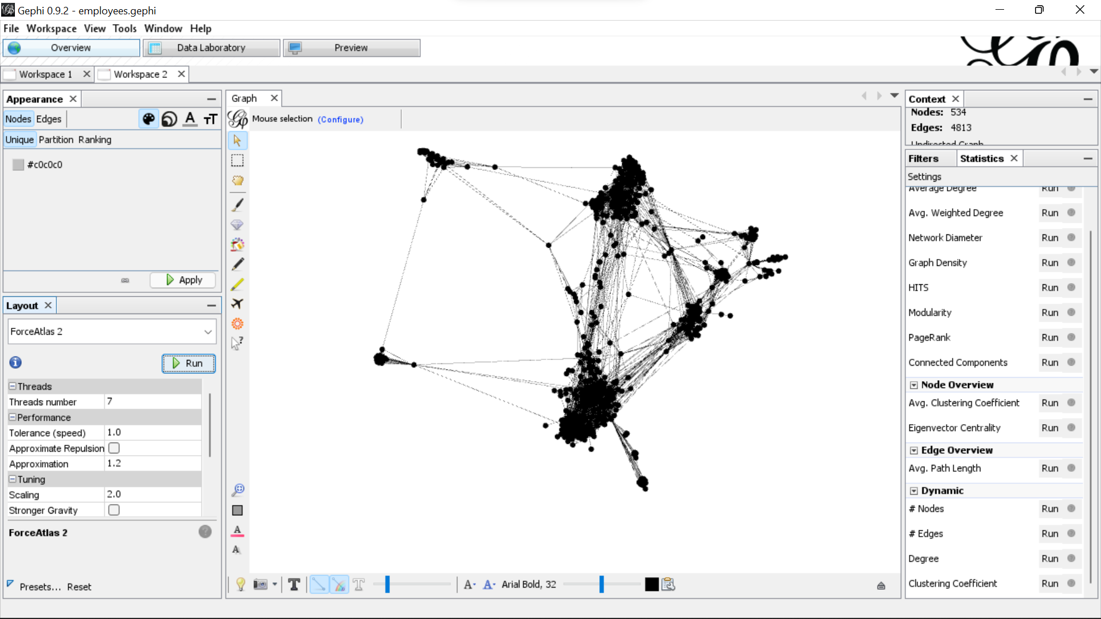

With overlap (ForceAtlas2)

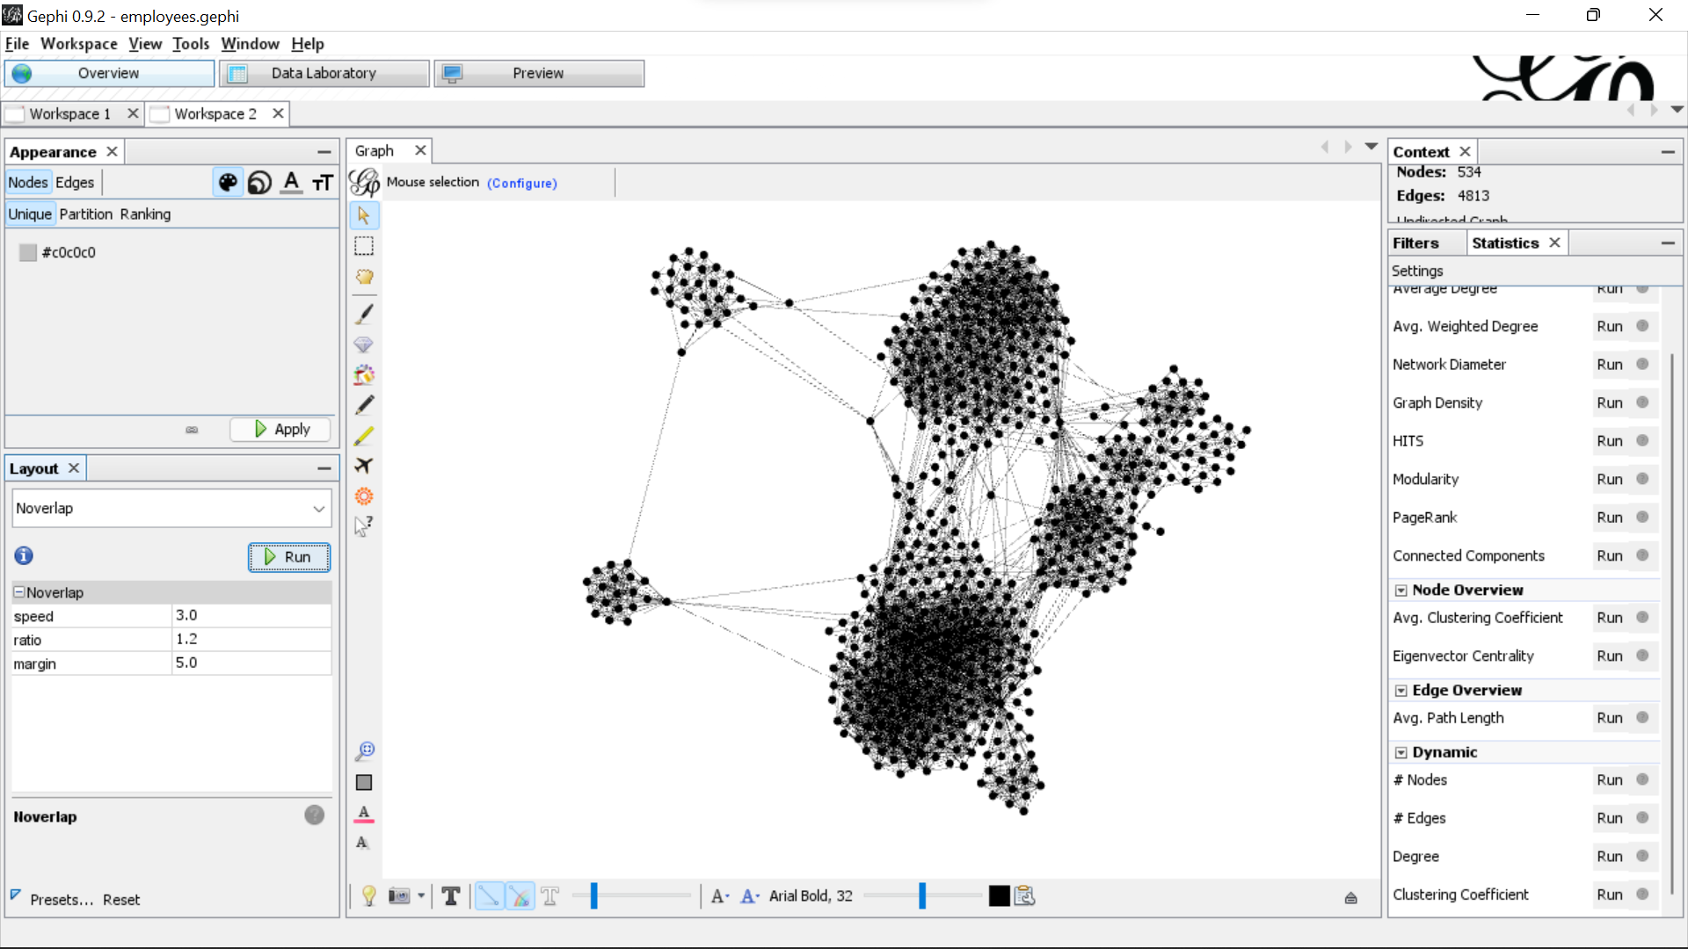

Without node overlap (Noverlap)

1. 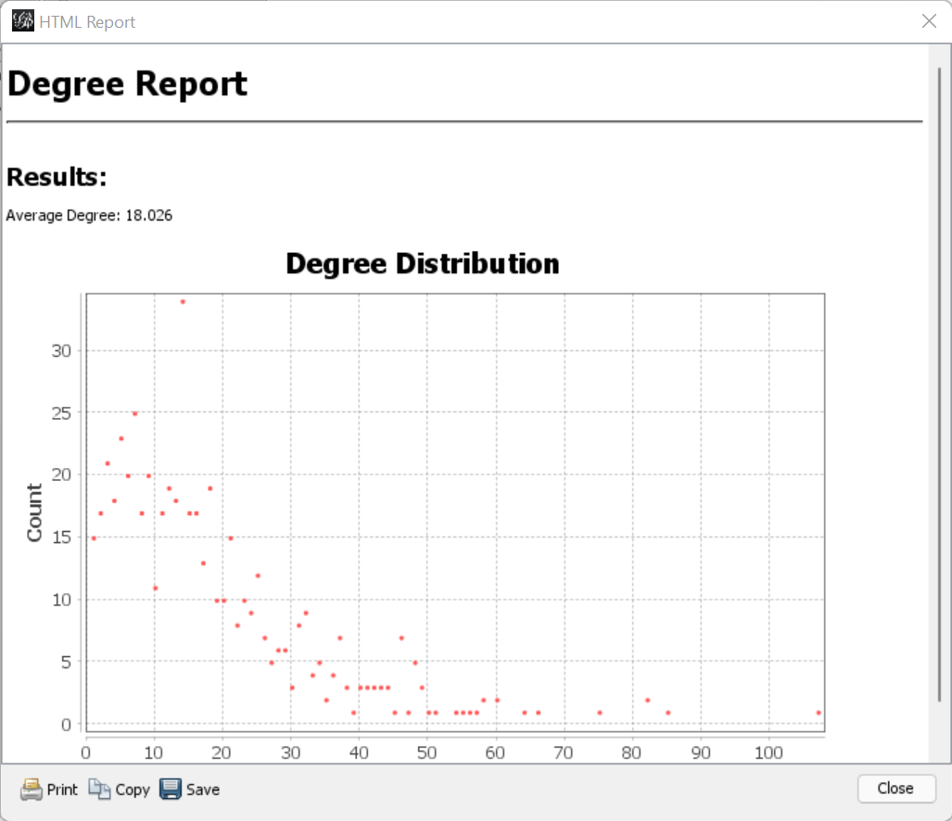



File with degree, closeness centrality and betweenness centrality computed.

Average degree of network: 18.026

1. 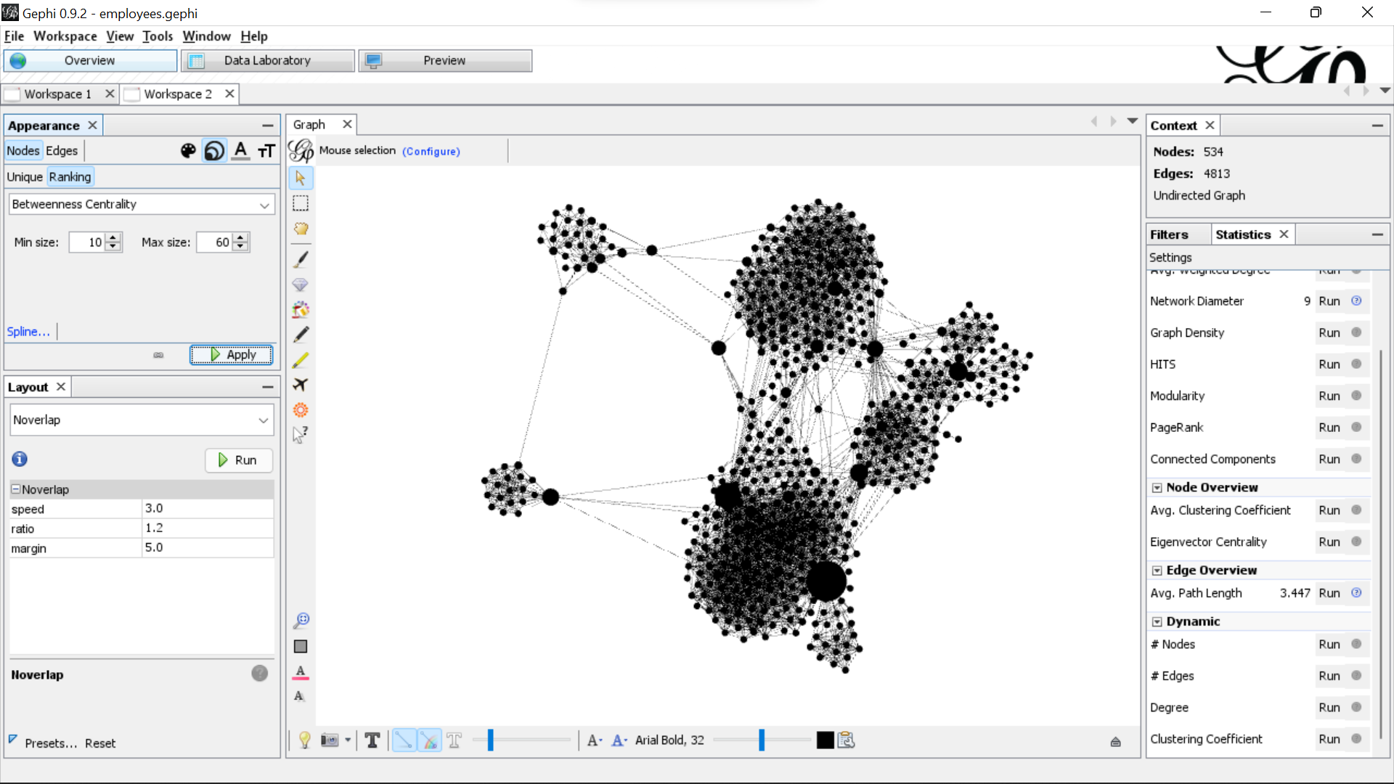
2. 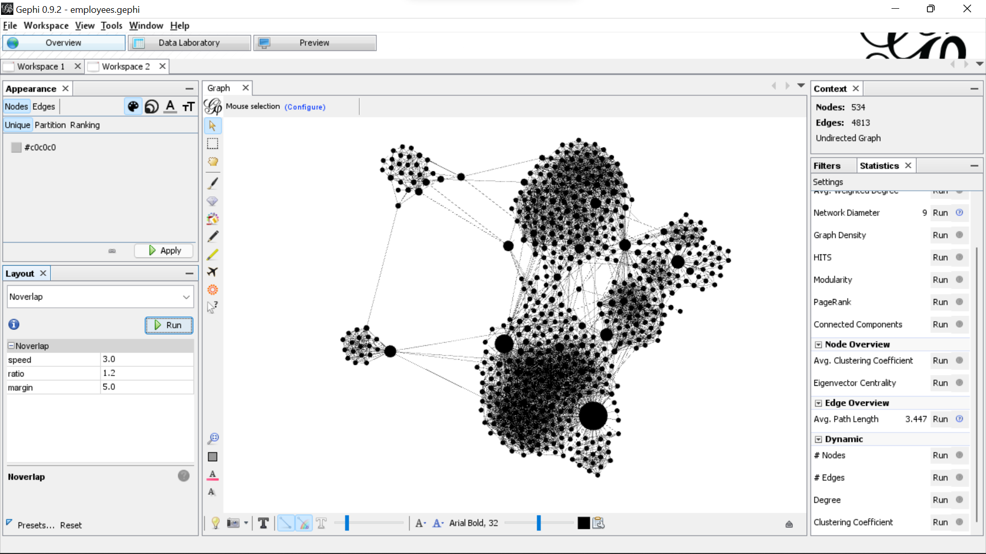
3. 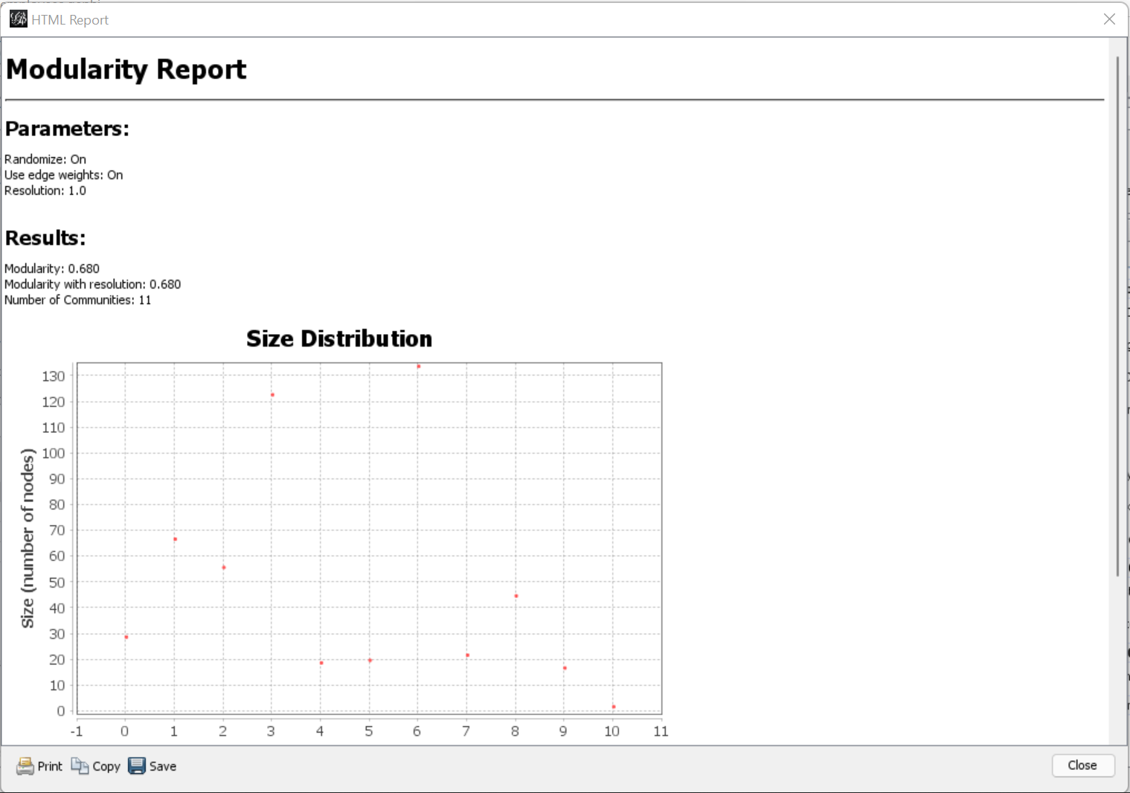
4. 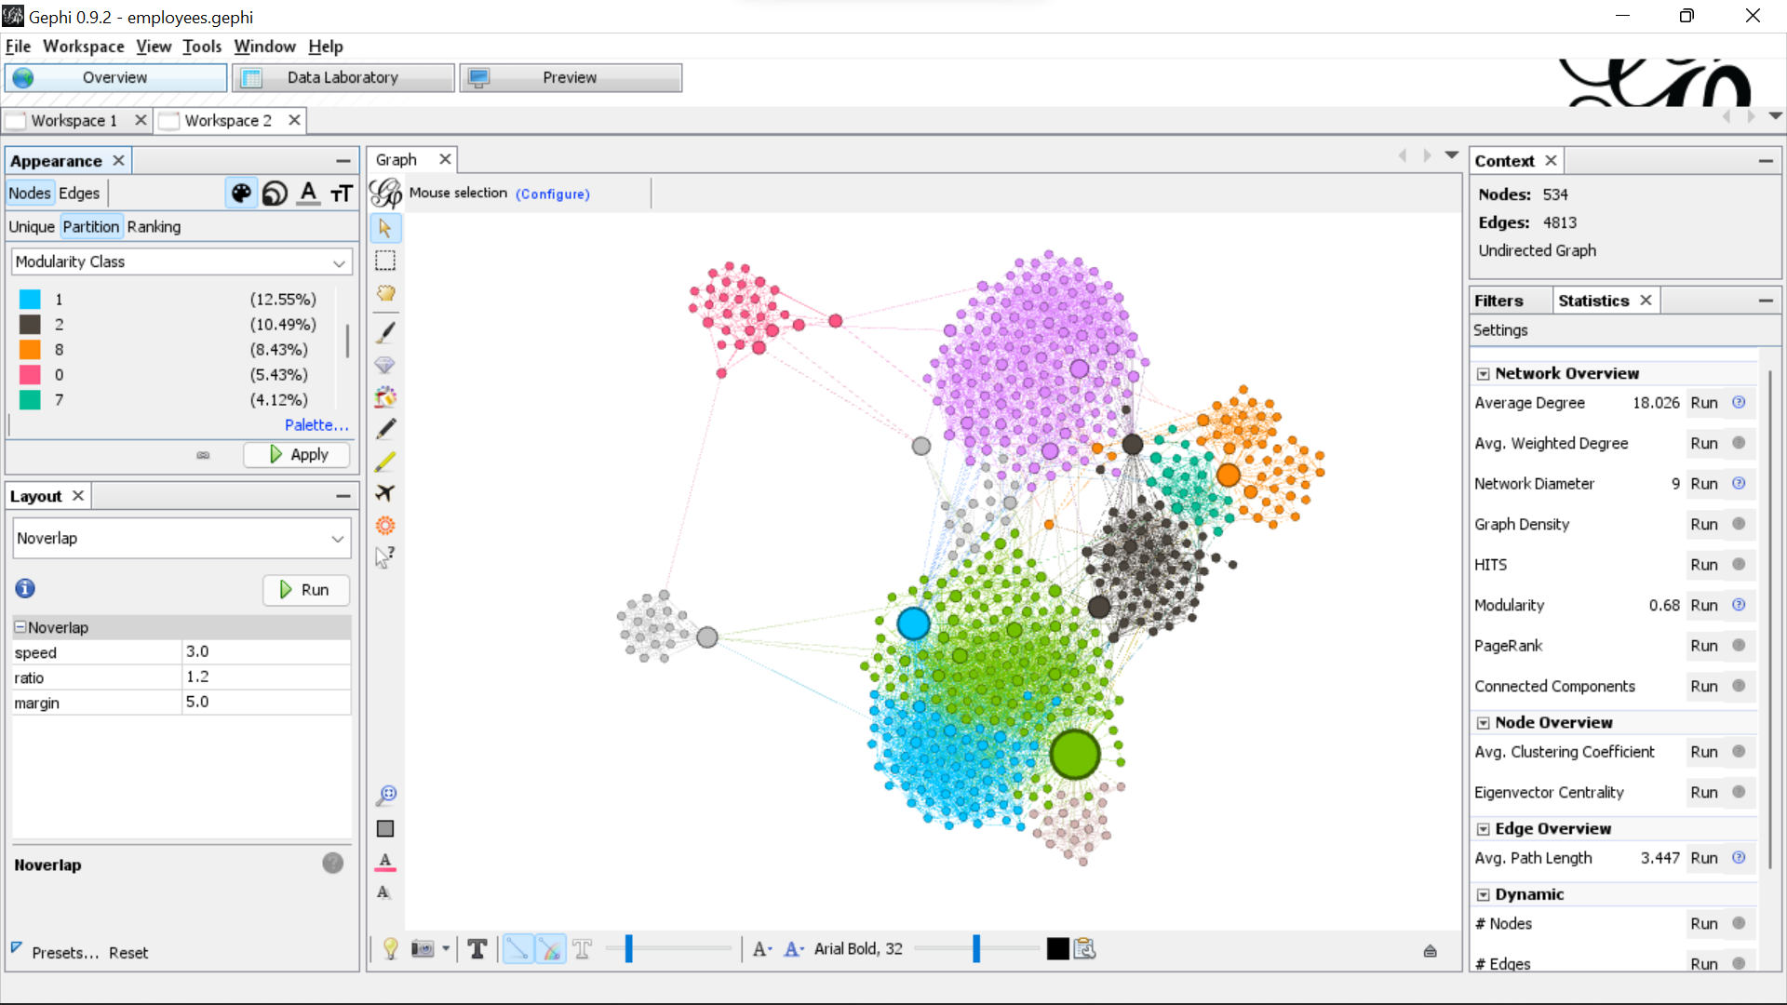

Clusters 1,3,5 have a large number of connections between them. Also, clusters 2,6,8 have a large number of connections between each other.

1. 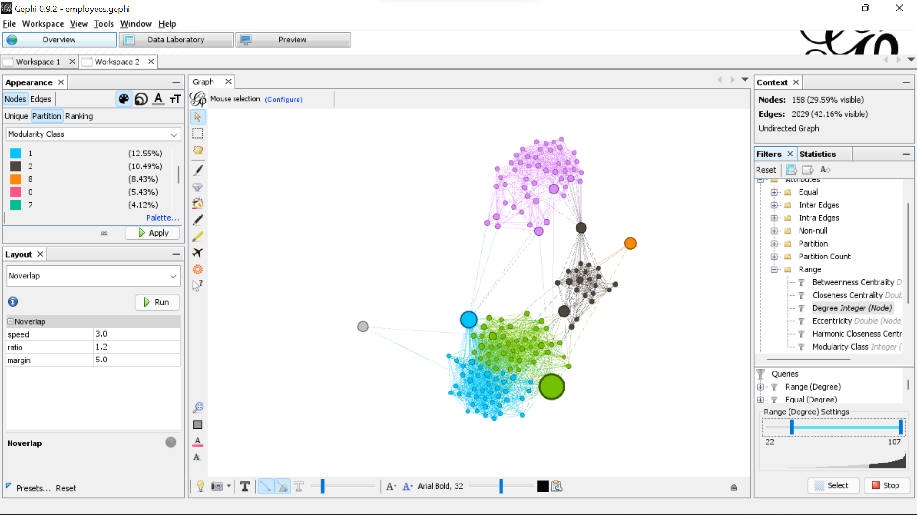
2. 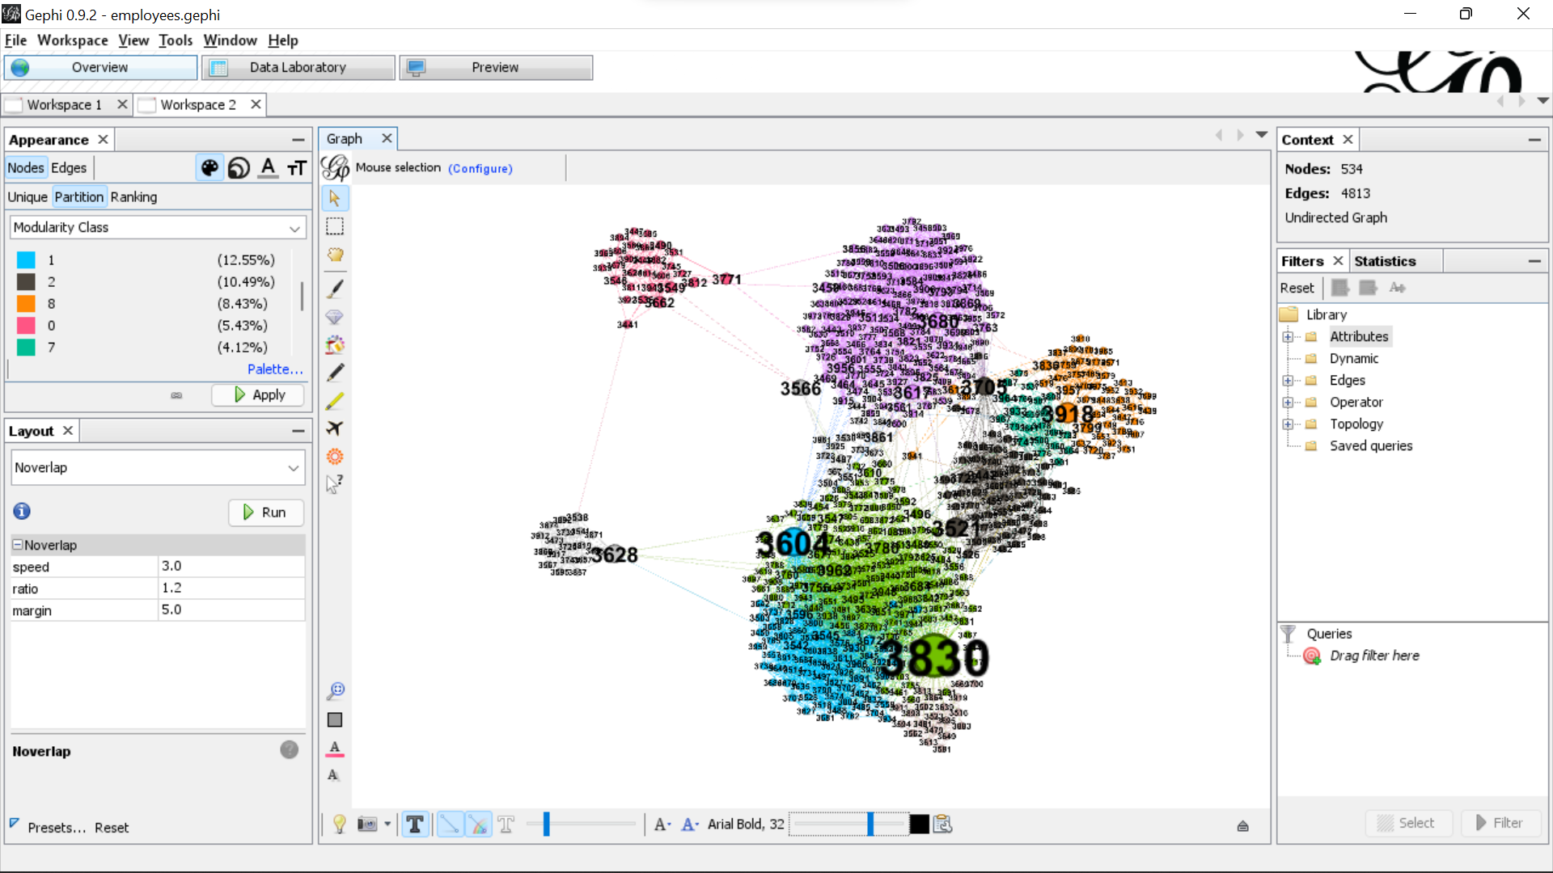
3. 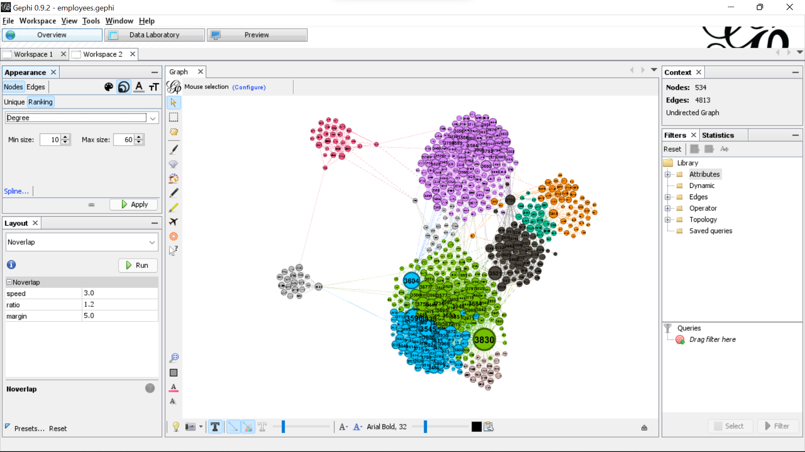

Yes, the graph changes as the nodes are now sized according to their degree rather than the between centrality. 3830 has the highest degree value. The green and blue clusters have nodes with higher degrees followed by the pink cluster when compared with the rest.

1. 

CC measures the speed with which an actor can spread the news over a network. Therefore, giving free samples to the node with the highest closeness centrality will make sure most people know about the product as soon as possible. Therefore, the free sample should be provided to node 3948.